Assigement-8(Nov 19-11-2018)

Single Level Inheritance

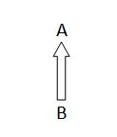

**class** Hero

{

**int** wheels=2;

**int** tank=1;

**int** chules=1;

**int** brakes=2;

**void** printHeroData()

{

System.***out***.println("No Of Wheels:"+wheels);

System.***out***.println("No Of tank:"+tank);

System.***out***.println("No of chules:"+chules);

System.***out***.println("No of brakes:"+brakes);

}

}

**class** Activa **extends** Hero

{

String color="White";

**int** gears=0;

**void** printActivaData()

{

System.***out***.println("Activa Properties");

System.***out***.println("---------------------");

System.***out***.println("No Of color:"+color);

System.***out***.println("No of gears:"+gears);

}

}

**public** **class** Bike {

**public** **static** **void** main(String[] args) {

Activa obj=**new** Activa();

obj.printActivaData();

obj.printHeroData();

}

}

Output:

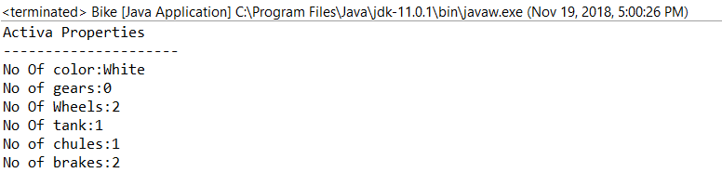

Multi-level Inheritance

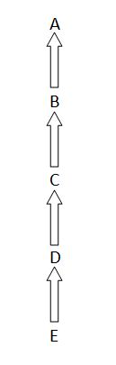

**class** Karishma

{

**int** wheels=2;

**int** tank=1;

**int** chules=1;

**int** brakes=2;

**void** printKarishmaData()

{

System.***out***.println("No Of Wheels:"+wheels);

System.***out***.println("No Of tank:"+tank);

System.***out***.println("No of chules:"+chules);

System.***out***.println("No of brakes:"+brakes);

}

}

**class** Jupiter **extends** Karishma

{

String color="White";

**int** gears=0;

**void** printJupiterData()

{

System.***out***.println("Jupiter Properties");

System.***out***.println("---------------------");

System.***out***.println("No Of color:"+color);

System.***out***.println("No of gears:"+gears);

}

}

**class** Apache **extends** Jupiter

{

String color="red";

**int** gears=5;

**void** printApacheData()

{

System.***out***.println("Apache Properties");

System.***out***.println("------------------------");

System.***out***.println("No of Color:"+color);

System.***out***.println("No Of gears:"+gears);

}

}

**class** Yamaha **extends** Apache

{

String color="blue";

**int** gears=6;

**void** printYamahaData()

{

System.***out***.println("Yamaha Properties");

System.***out***.println("------------------------");

System.***out***.println("No of Color:"+color);

System.***out***.println("No Of gears:"+gears);

}

}

**public** **class** MultiLevel {

**public** **static** **void** main(String[] args) {

Yamaha obj1=**new** Yamaha();

obj1.printYamahaData();

obj1.printKarishmaData();

obj1.printApacheData();

obj1.printJupiterData();

}

}

Output:

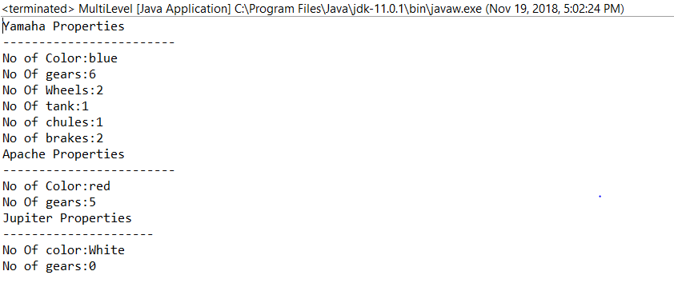

Hierarchal

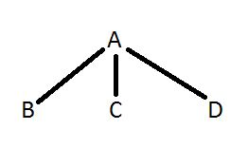

**class** Sony

{

**int** screen=1;

**int** remote=1;

**void** printSonyData()

{

System.***out***.println("No Of screen:"+screen);

System.***out***.println("No Of Remote:"+remote);

}

}

**class** Model1 **extends** Sony

{

String color="black";

**int** size=34;

**void** printModel1Data()

{

System.***out***.println("No Of Color:"+color);

System.***out***.println("No Of size:"+size);

}

}

**class** Model2 **extends** Sony

{

String color="blue";

**int** size=42;

**void** printModel2Data()

{

System.***out***.println("No Of Color:"+color);

System.***out***.println("No Of size:"+size);

}

}

**class** Model3 **extends** Sony

{

String color="red";

**int** size=44;

**void** printModel3Data()

{

System.***out***.println("No Of Color:"+color);

System.***out***.println("No Of size:"+size);

}

}

**public** **class** Hierarichal {

**public** **static** **void** main(String[] args) {

System.***out***.println("Model1 Details");

System.***out***.println("----------------------");

Model1 obj=**new** Model1();

obj.printSonyData();

obj.printModel1Data();

System.***out***.println("Model2 Details");

System.***out***.println("----------------------");

Model2 obj2=**new** Model2();

obj.printSonyData();

obj2.printModel2Data();

System.***out***.println("Model3 Details");

System.***out***.println("----------------------");

Model3 obj3=**new** Model3();

obj.printSonyData();

obj3.printModel3Data();

}

}

Output:

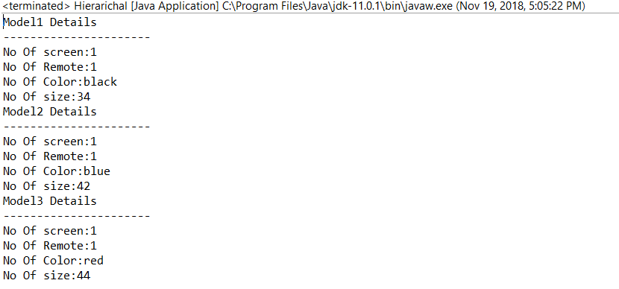

Multiple

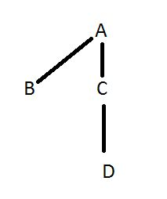

**class** Iphone

{

**int** screen=1;

**int** battery=1;

**void** printIphoneData()

{

System.***out***.println("No Of screen:"+screen);

System.***out***.println("No Of battery:"+battery);

}

}

**class** Version1 **extends** Iphone

{

String color="black";

**float** size=3.5f;

**int** ram=512;

**void** printVersion1Data()

{

System.***out***.println("No Of Color:"+color);

System.***out***.println("No Of size:"+size);

System.***out***.println("No Of Ram Size:"+ram);

}

}

**class** Version2 **extends** Iphone

{

String color="blue";

**int** size=4;

**int** ram=2;

**void** printVersion2Data()

{

System.***out***.println("No Of Color:"+color);

System.***out***.println("No Of size:"+size);

System.***out***.println("No Of Ram Size:"+ram);

}

}

**class** Version3 **extends** Version2

{

String color="red";

**int** size=5;

**int** ram=4;

**void** printVersion3Data()

{

System.***out***.println("No Of Color:"+color);

System.***out***.println("No Of size:"+size);

System.***out***.println("No Of Ram Size:"+ram);

}

}

**public** **class** Hierarichal2 {

**public** **static** **void** main(String[] args) {

System.***out***.println("Version1 Details");

System.***out***.println("----------------------");

Version1 obj=**new** Version1();

obj.printIphoneData();

obj.printVersion1Data();

System.***out***.println("Version2 Details");

System.***out***.println("----------------------");

Version2 obj2=**new** Version2();

obj2.printIphoneData();

obj2.printVersion2Data();

System.***out***.println("Version3 Details");

System.***out***.println("----------------------");

Version3 obj3=**new** Version3();

obj2.printVersion2Data();

obj3.printVersion3Data();

}

}

Output:

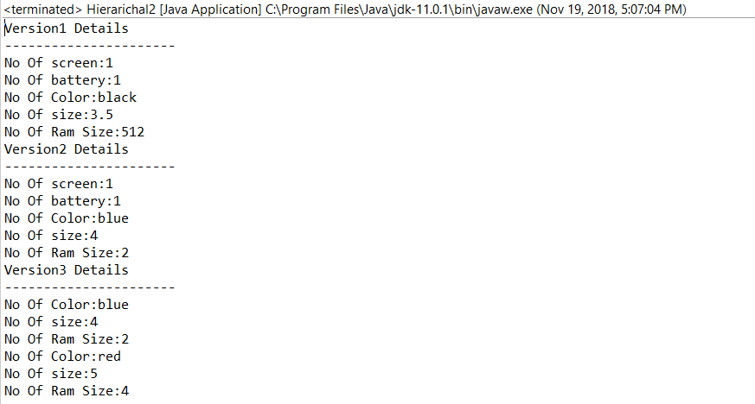

Multiple 2

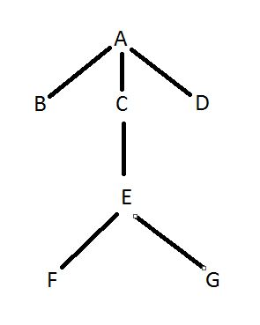

**class** Teacher

{

String subject="science";

**void** printTeacherData()

{

System.***out***.println("No Of Subject:"+subject);

}

}

**class** Standard1 **extends** Teacher

{

**int** no=34;

**void** printStandard1Data()

{

System.***out***.println("No Of Students:"+no);

}

}

**class** Standard2 **extends** Teacher

{

**int** no=42;

**void** printStandard2Data()

{

System.***out***.println("No Of Students:"+no);

}

}

**class** Standard3 **extends** Teacher

{

**int** no=44;

**void** printStandard3Data()

{

System.***out***.println("No Of Students:"+no);

}

}

**class** Standard4 **extends** Standard3

{

String name="kalyan";

**void** printStandard4Data()

{

System.***out***.println("Name Of Student:"+name);

}

}

**class** Standard5 **extends** Standard4

{

String name="krishna";

**void** printStandard5Data()

{

System.***out***.println("No Of Students:"+name);

}

}

**class** Standard6 **extends** Standard4

{

String name="siva";

**void** printStandard6Data()

{

System.***out***.println("No Of Students:"+name);

}

}

**public** **class** Hierarichal3 {

**public** **static** **void** main(String[] args) {

System.***out***.println("Standard1 Details");

System.***out***.println("-------------------------------------");

Standard1 obj=**new** Standard1();

obj.printTeacherData();

obj.printStandard1Data();

System.***out***.println("Standard2 Details");

System.***out***.println("--------------------------------------");

Standard2 obj2=**new** Standard2();

obj.printTeacherData();

obj2.printStandard2Data();

System.***out***.println("Standard3 Details");

System.***out***.println("--------------------------------------");

Standard3 obj3=**new** Standard3();

obj3.printTeacherData();

obj3.printStandard3Data();

System.***out***.println("Standard4 Details");

System.***out***.println("--------------------------------------");

Standard4 obj4=**new** Standard4();

obj4.printTeacherData();

obj4.printStandard3Data();

obj4.printStandard4Data();

System.***out***.println("Standard5 Details");

System.***out***.println("--------------------------------------");

Standard5 obj5=**new** Standard5();

obj5.printTeacherData();

obj4.printStandard4Data();

obj5.printStandard5Data();

System.***out***.println("Standard6 Details");

System.***out***.println("--------------------------------------");

Standard6 obj6=**new** Standard6();

obj6.printTeacherData();

obj4.printStandard4Data();

obj6.printStandard6Data();

}

}

Output:

